HOW DID I START MY BRAND!?

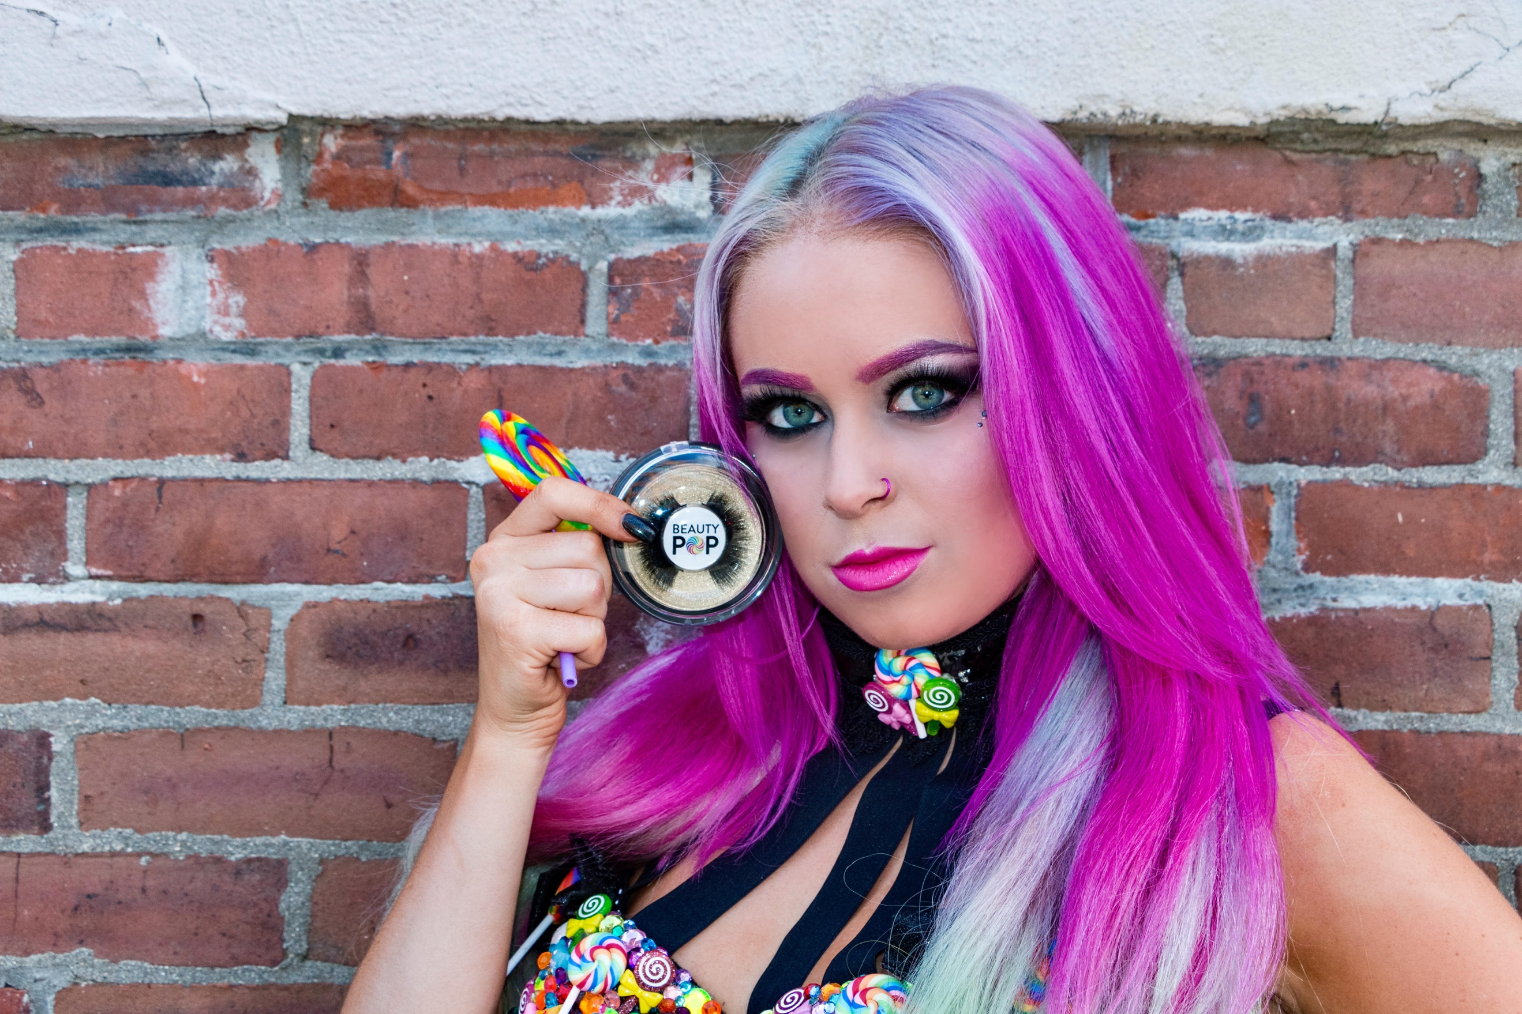

MY NAME IS ASHLEY ARCIERO OWNER OF BEAUTYPOPLASHES! MY PASSION HAS ALWAYS BEEN HAIR & MAKEUP & WANTING TO START MY OWN LINE. RECENTLY I TOOK THE STEP TO ACHIEVE MY GOAL & LAUNCHED MY BRAND! I STARTED WITH THE PRODUCT MINK FALSE EYELASHES BECAUSE THEY ARE MY FAVORITE ACCESSORY WHEN DOING MY OWN MAKEUP. PEOPLE OFTEN ASK ME HOW I CAME UP WITH THE NAME. THE WORD BEAUTYPOP HAS ALOT OF MEANING TO ME. I HAVE ALWAYS LOVED BEAUTY, MODELING, & FASHION. I THINK EVERYONE HAS A BEAUTYPOP IN THEMSELVES & SHOULD BRING THAT OUT! MY BEAUTYPOP IS MY HAIR I ALWAYS LOVE TO SWITCH IT UP & DO FUNKY COOL COLORS! ANOTHER REASON WHY I CHOOSE THIS NAME IS BECAUSE I HAVE A FRIEND WHO PASSED AWAY WHO WOULD ALWAYS CALL ME LOLIPOP. HE INSPIRED ME. LOLLIPOPS ARE SUPER COLORFUL AND FUN AND I THOUGHT HOW PERFECT WOULD THIS BE FOR THE NAME! RIP PAUL & THANK YOU FOR MAKING ME STEP UP TO START MY BRAND! STAY TUNED FOR MORE PRODUCTS!!